NAME USAMA
ROLL NUMBER O38
AI TASK NO 08
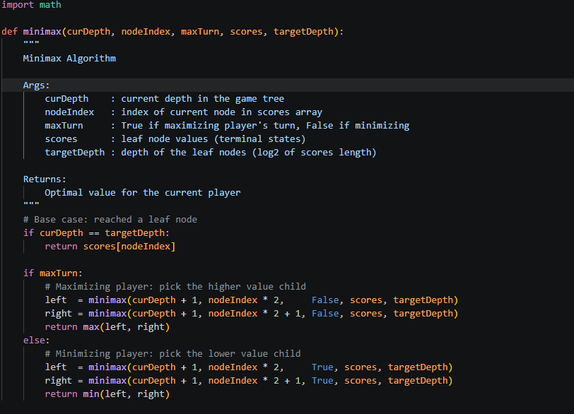
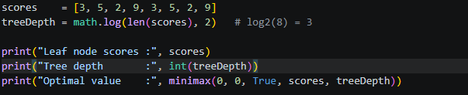

OUTPUT
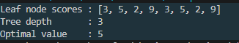
How it works (tracing the tree):
Depth 0 [MAX]: MAX(3, 2) = 3 ← optimal
/ \
Depth 1 [MIN]: MIN(3,5)=3 MIN(2,9)=2
/ \ / \
Depth 2 [Leaves]: 3 5 2 9
The MAX player at the root picks between 3 and 2, so the optimal value is 3

